**Basix of Programming**

**Student Name:** Priyanshu Kumar

**Subject Code:** 21CAH623

**UID: 21MCC2088 Section/Group B**

**Semester: 2 Date of Performance: 20/02/2022**

**Experiment No. 1**

1. **Aim/Overview of the practical:**

**Task to be done:**

**Experiment No. 1:** Write a Python program to create a sequence where the first four members of the sequence are equal to one, and each successive term of the sequence is equal to the sum of the four previous ones. Find the Nth member of the sequence.

1. **Code for experiment/practical:**

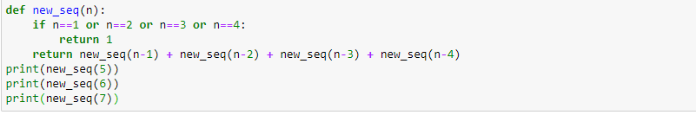

**2 Result/Output/Writing Summary:**

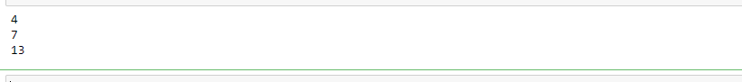

**Learning outcomes (What I have learnt):**

**1.to make sequence in python**

**2. how to use Anaconda platform for this performance.**

**Evaluation Grid:**

|  |  |  |  |
| --- | --- | --- | --- |
| Sr. No. | Parameters | Marks Obtained | Maximum Marks |
| 1. | Demonstration and Performance (Pre Lab Quiz) |  | 5 |
| 2. | Worksheet |  | 10 |
| 3. | Post Lab Quiz |  | 5 |